**PHASE 6 - User Interface Development**

This phase focuses on building a responsive and intuitive user interface using the Lightning App Builder and custom Lightning Web Components (LWC).

**♦️ Lightning App Builder**

The Lightning App Builder was the primary tool for creating the app and customizing pages declaratively.

* **App Creation**: A dedicated Lightning App named "QuickServe Console" was built to provide a focused workspace for staff and managers.
* **Utility Bar**: Standard utilities like "History" and "Notes" were added to the app's utility bar for easy access to common tools.

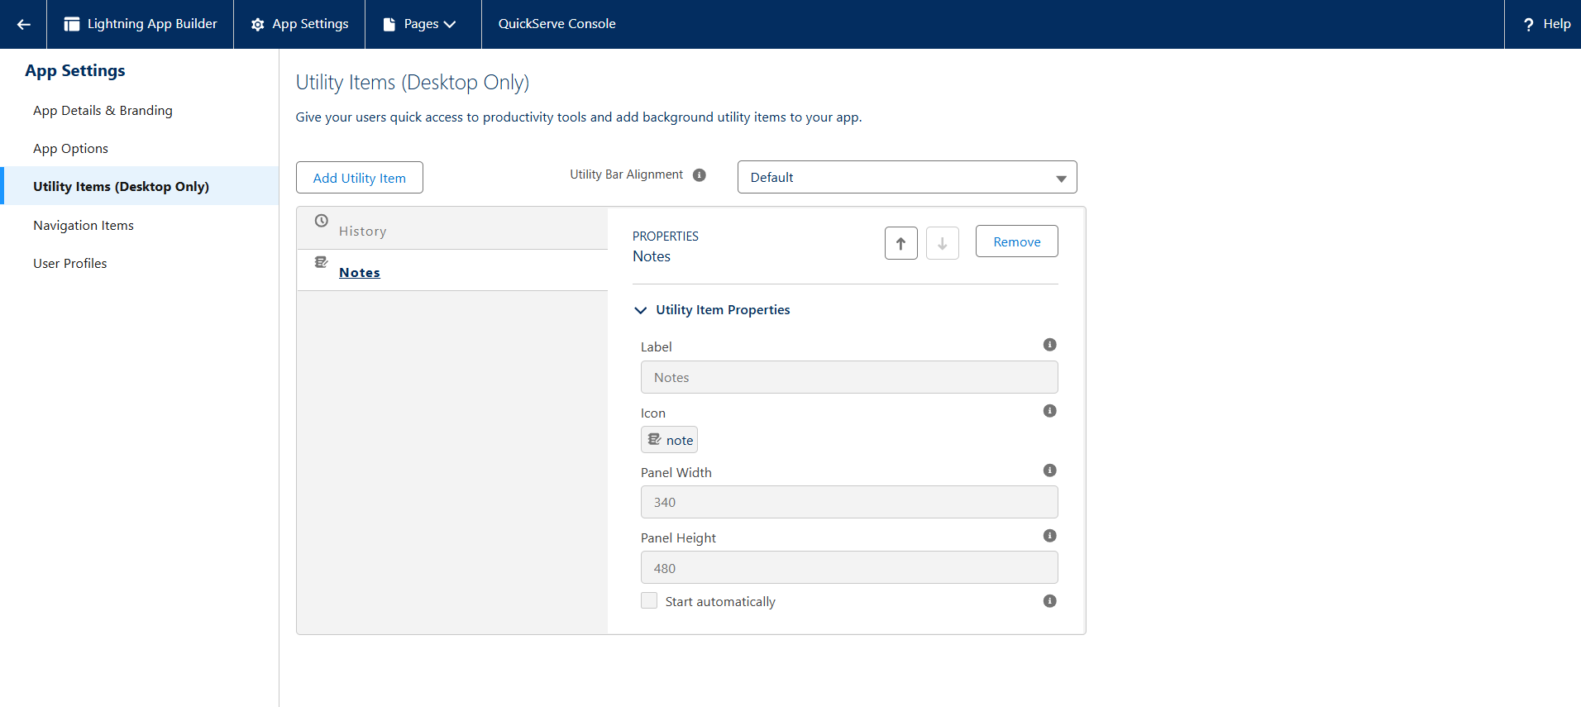

**♦️ Record Pages & Tabs**

The standard Contact record page was enhanced to serve as the central hub for all customer-related activities.

* **Custom Tabs**: The page was configured to include custom tabs for "Orders," "Reservations," and "Loyalty Program," each containing a related list to show the relevant records.

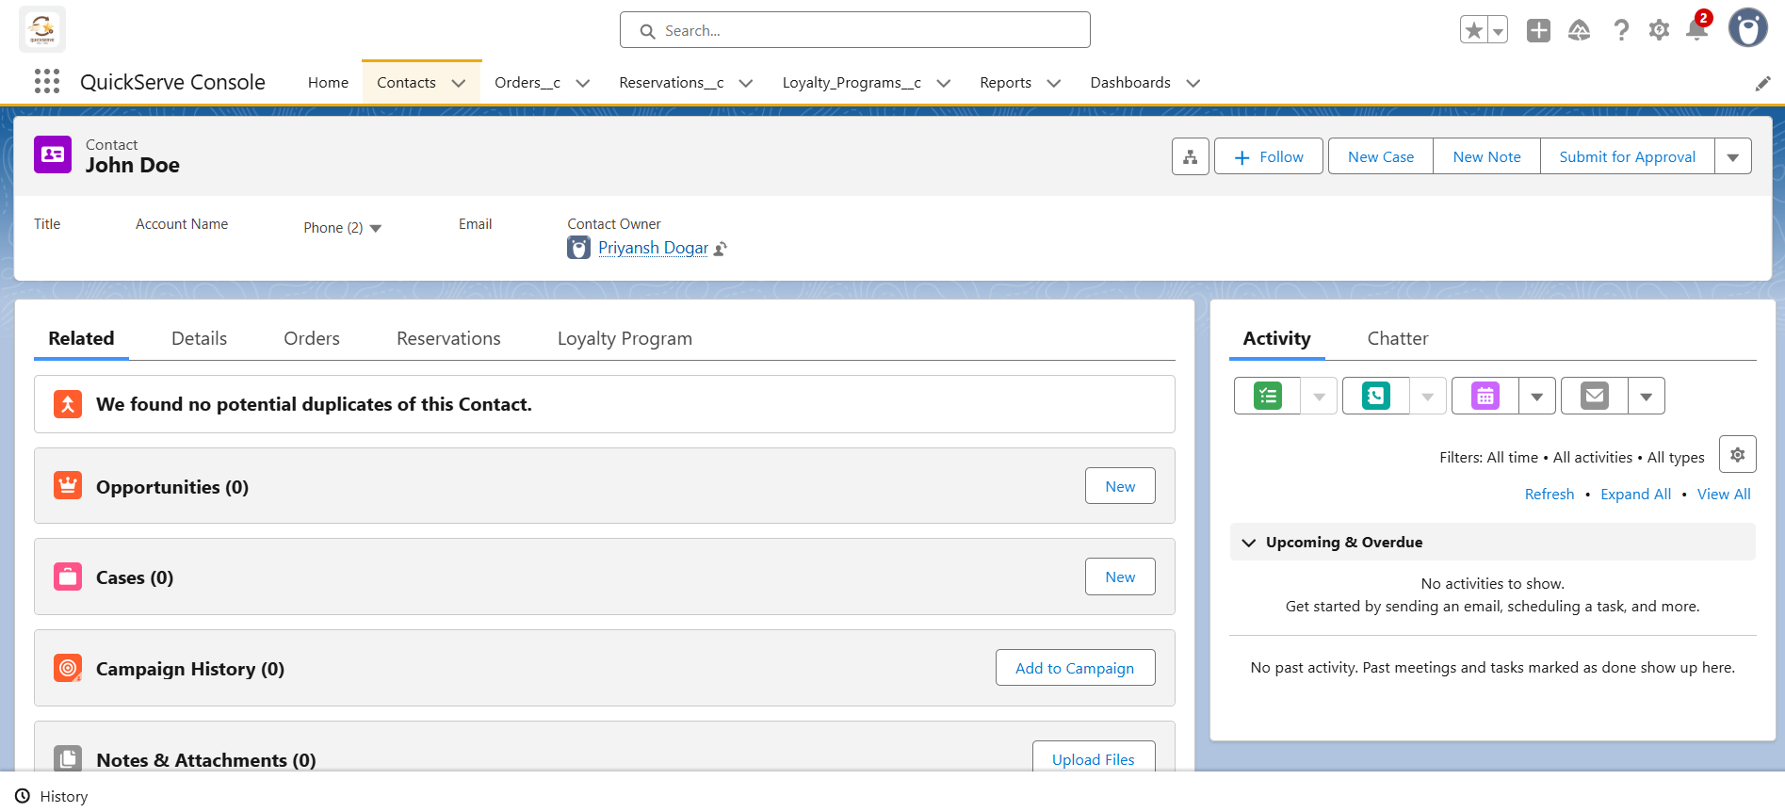

**♦️ Lightning Web Components (LWC)**

A custom Lightning Web Component (loyaltyPointsDisplay) was developed to provide a real-time view of a customer's loyalty status.

* **Apex with LWC**: The LWC communicates with a dedicated Apex class (LoyaltyController) to fetch data from the server. The Apex method is annotated with @AuraEnabled(cacheable=true) to make it securely accessible to the component.
* **Wire Adapters**: The component's JavaScript uses the @wire adapter to call the Apex method reactively. This automatically provides the data from the server and re-renders the component when the data changes.
* **Imperative Apex Calls**: While the display component uses a wire adapter, a future enhancement like a "Manual Points Adjustment" tool would use an imperative Apex call, as it needs to run in response to a user action (like a button click) and perform a DML operation.

